Chapter 7, Solution 48.

For t < 0, 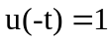,

For t > 0,  